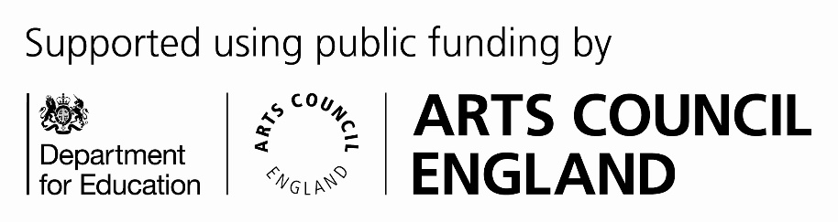

**Music Service**

Service level agreement

2024/25

**Contents**

1. Service description
2. Service delivery
3. Customer obligations
4. Notice period

Appendix A – Key Performance Indicators

Appendix B – Charges

1. Service description

Wider Opportunities

Whole class instrumental delivery cover one of the core areas in the governments National Plan for Music Education. **We are able to subsidise delivery so that effectively you receive one term free**. Schools are offered up to 39 one-hour whole class sessions (depending on teacher availability). All the packages include free instruments, and we currently offer the free Active Music Singing resource.

The music teacher will plan lessons, liaise with school staff over delivery and report on pupil progress.

**(Please note that if you are using sessions to cover PPA time, we cannot guarantee a cover teacher in the case of illness to one of our own staff and will not be able to cover the cost of replacement cover as the fee for this programme is already heavily subsidised)**

Large Group

This buy back option is for up to 32 sessions per year, paid retrospectively at the end of every term. This option is for those wishing to develop an ensemble (not curriculum linked) for existing instrumental pupils or for those who have been having whole class lessons for a year. A specialist instrumental instructor is provided, who will work side by side with your classroom teacher if required. Ideally this is for extra-curricular clubs and ensembles.

Teaching Block

These are flexible sized instrumental lessons. Ideal for beginners, GCSE or A Level pupils where the school wishes to buy a block of time to use as they see fit. Up to 32 sessions per year can be purchased. The time can be divided according to need. Schools can then decide how they wish to charge parents. The time is fixed for a term and requires a half terms notice for a reduction in time bought in.

Workshops

Bespoke delivery. Workshops can include samba, djembe, instrumental or other according to demand.

Curriculum Delivery/Support

Curriculum delivery or CPD support according to need. This can be purchased on an hourly basis. Examples might include teaching time, support for GCSE moderation, development of current music curriculum, support for gaining Arts Mark, composition assessment, Early Years music or any other requirements.

Instruments Only

It is possible to hire class sets of instruments for a specific amount of time, dependant on their availability.

1. Service delivery

The Music Service:

* Head of Service
* Assistant Head of Service x 2 (1 FTE)
* Music Centre Manager x 5
* Instrumental Leads x3
* Teaching staff
* Admin Team (Business Support)
* Each Customer will have contact points (telephone and email) for the Head of Service or Assistant Head of Service plus admin team.
* Key personnel from the team are listed below:

|  |  |  |  |
| --- | --- | --- | --- |
| Title | Name | Telephone | Email |
| Head of Service | Ian Bangay | 01609 532790 | Ian.bangay@northyorks.gov.uk |
| Assistant Head | Chris Hirst (Mon-Wed)  Ryan Watkins (Thurs-Friday) | 01609 536805  07814 935903 | [Chris.hirst@northyorks.gov.uk](mailto:Chris.hirst@northyorks.gov.uk)  Ryan.Watkins@northyorks.gov.uk |
| Susan Marks | Admin Team 01609 535730 Susan.marks@northyorks.gov.uk | | |
| Jane Atkinson | Admin/Booking 01609 534980 | | |

1. Customer obligations

Schools should ensure that suitable teaching spaces are available for activities to take place. This is particularly important for whole class instrumental teaching.

For instrumental ensemble teaching, a school-based member of staff needs to be present, if done during school time and an onsite member of staff contactable if done as an after school activity.

Please note, we cannot guarantee cover for lessons where a member of our staff is absent at short notice. The service operates across the county and all staff have full timetables. We do not have spare staff available.

We will endeavour to find you your preferred time/day. However, if booking in terms 2 or 3 only, we cannot guarantee your preferred teaching day/time as our teachers timetables get full in term 1. This may not allow for timetable changes in terms 2 and 3.

After the initial free accessories e.g. reeds, keyboard adaptors, strings have worn out, schools will be responsible for buying spares.

1. Notice Period

The Music Service operates on an annual contract with a minimum of half a term notice of change or termination.

Appendix A – Key Performance Indicators

To provide an efficient and effective service that is responsive to customer needs, provides accurate and timely advice and information and monitors satisfaction through feedback, and peer review processes.

Performance indicators

1. Provision of whole class programmes that meet the requirements of the school and meets the outcomes identified in the National Plan for Music Education.
2. Provision of effective guidance, advice and support in relation to the music curriculum, instruments and quality of teaching.
3. Meet the requirements made of us by Arts Council England as lead organization in the North Yorkshire Music Hub.
4. Effective delivery of the Schools Music Education Plan as part of North Yorkshire Music Hub

**How we will measure the KPI’s**:

Through annual data collection exercise and reporting procedures to Arts Council England

Annual lesson observation cycle of all staff

Through feedback from schools, parents and Instrumental Leads.

Yearly updating of Music Service Improvement Plan

Appendix B – Charges

|  |  |  |
| --- | --- | --- |
| Package | Pricing | 2023/24 Primary and Secondary |
| Instrumental Teaching Block | Per hour | 52.80 |
| Instruments Only | Per term | 163.20 |
| Large Group Instrumental Ensemble Sessions | Per hour | 52.80 |
| Whole Class Music Curriculum Sessions | Per hour | 52.80 |
| Whole Class Instumental NPME | Per Academic Year | 1168 |
| GCSE Tuition | Per Hour | 52.80 |